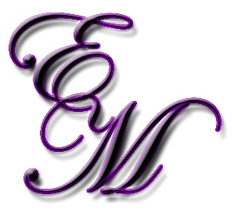
Luxury Amethyst Package
All Inclusive – Choose Your Destination – Define Your Style – Relax & Enjoy the Magic of Planning!
Starts at 20% of wedding budget; $75,000 minimum (budget)
Destination Locations starts at 25% of wedding budget (within U.S.); and 35% (International); $95,000 minimum (budget)
50% of deposit due at time of signing contract - Final due two weeks prior to event
- Create your perfect vision with this stress free, all-inclusive wedding design package
- Work exclusively with ENCHANTED MOMENTS Owner, Leslie Joyner-Spitzner, who is with you from your first steps of planning, until you finally take those momentous steps down the aisle
- Utilize our team of vendors and easy planning process to create the wedding of a lifetime
- Coordinating hotel accommodations, transportation and child care (if applicable)
- Facilitate Wedding Rehearsal, Wedding Rehearsal Dinner, Sunday Wedding Brunch
- Show up on your wedding day ready to say 'I Do!' as we manage all vendors and contracts
- Perfect for destination brides
- Create a beautiful and flawless wedding day during planning sessions while taking full use of local resources
- Enjoy the process beginning with your vision board as your designer (with chosen vendor and assistance by planner) develops a seamless experience
- Assembling Save the Dates & Wedding Invitations
- Assistance with tracking RSVP’s
- Wedding Weekend planning assistance included
- Assemble and delivering to guest hotel room Welcome Bags
- Additional assistants provided throughout process and day of Wedding
- This package is all our packages wrapped up in one, for a full elegant planned and coordinated experience
All travel arrangements MUST be made for planners that are attending wedding. Ex. Hotel & Lodging, Airfare, Transportation, etc. (see contract for more details)

