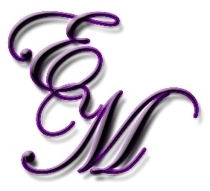
Crystal Package
Personalized Quote for each event as it will be customized!
Starts with hourly rate of $100.00/or customized packaged pricing
These services are for Event Planning Services Only: Your event is your desire; we are here to make desires unforgettable memories that last a Lifetime! Bridal Showers, Baby Showers, Bachelor/Bachelorette Parties, Children & Adult Birthday Parties, Family Reunions, Anniversary Parties, Holiday Parties, Business Meetings (Luncheons), Social Events, Engagement Parties, Etc.

- Initial one (1) hour meeting complimentary
- Up to 6 hours of service; any additional hours will be at $95.00 an hour
- Full Service planning
- Day of Coordination
- Invitation assistance
- Decoration setup
- Initial Site Visit
- Menu Development
- Vendor research and/or referral
- Confirm vendor details
- Vendor contract review
- Visit site for event
- Create timeline
- Guest rsvp tracking
- Creative ideas per event
- Budget assistance
- Hotel Room Block
- Create Timeline (if applicable)

Prices are Subject to Change Without Notice & Not Guaranteed Until Contract is signed

